Simple Applet Program

import java.applet.\*;

import javax.swing.\*;

import java.awt.event.\*;

/\* <applet code="EventJApplet" width=200 height=200> </applet> \*/

public class EventJApplet extends JApplet implements ActionListener

{

JButton b;

JTextField tf;

public void init()

{

tf=new JTextField();

tf.setBounds(80,40,240,20);

b=new JButton("Click");

b.setBounds(170,80,70,20);

add(b);

add(tf);

b.addActionListener(this);

setLayout(null);

}

public void actionPerformed(ActionEvent e)

{

tf.setText("Welcome to Java Programming World" );

}

}

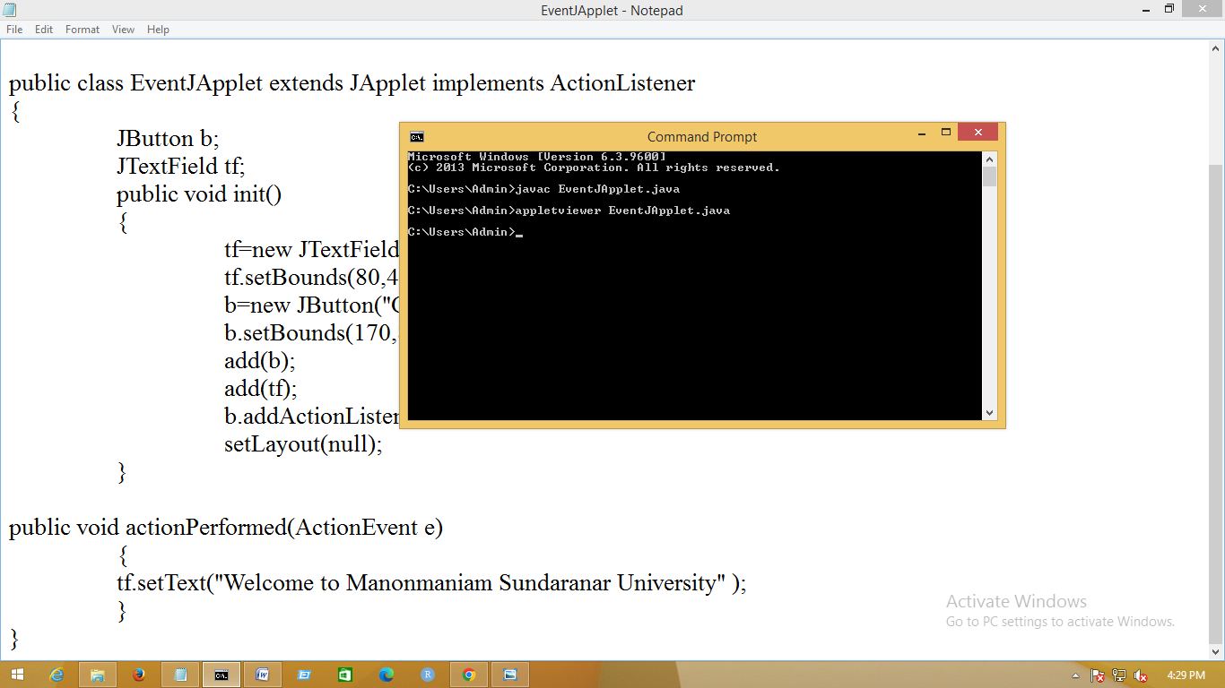

C:\Users\Admin>javac EventJApplet.java

C:\Users\Admin>appletviewer EventJApplet.java

C:\Users\Admin>

